Utilizing EWN for Water, Sediment, and Contaminant Management in Agricultural Areas in the Midwest and Great Plains Regions

September 5, 2023

|  |  |
| --- | --- |
| Co-PRINCIPLE INVESTIGATORS | |
| Name: Dr. Todd E. Steissberg  Org. Code: U433D90  Name: Dr. Charles W. Downer  Org. Code: U430510 | Email:  Todd.E.Steissberg@usace.army.mil  Phone Number: (530) 574-5572  Email: Charles.W.Downer@usace.army.mil  Phone Number: (305) 458-8443 |
| TEAM MEMBERS | |
| Name: Dr. Nawa Pradhan  Org. Code: U430510  Name: Dr. Billy Johnson  LimnoTech, Inc.  Name: Dr. Aaron Byrd  Org. Code: U430510  Name: Dr. Rose Shillito  Org. Code: U430550 | Email: Nawa.Pradhan@usace.army.mil  Email: Billy.E.Johnson@usace.army.mil  Email: Aaron.R.Byrd@erdc.dren.mil  Rose.M.Shillito@erdc.dren.mil |
| FUNDING REQUESTED | |
| PROJECT TOTAL: $950k | |



# Project Background

## Project Abstract (1/2 page)

Extensive modifications of the landscape in the continental U.S. Great Plains and Midwest for agriculture has completely changed the hydrologic, sediment transport, and water quality characteristics of watersheds and streams in the regions. This has had profound effects on receiving water bodies downstream of extensively farmed areas: streams, rivers, lakes, and reservoirs, with erosion/sedimentation, water quality, aquatic species with increased flooding, stream instability, and impaired uses: recreation, drinking water, fishing, etc. Moreover, there is recent evidence that agricultural runoff contributes to climate change through the release of nitrous oxide, a potent greenhouse gas, in the rivers and streams that receive runoff from agricultural lands (Winnick, 2021; https://www.nsf.gov/discoveries/disc_summ.jsp?cntn_id=303860&org=NSF&from=news). The broad objective of this project is to facilitate the application of Engineering with Nature (EWN) to intensively farmed areas in the Great Plains and Midwest regions. In order to design sustainable EWN infrastructure, more accurate estimates of exported nutrients and contaminants need to be developed. This project will integrate nutrient and contaminant fate and transport processes within the Gridded Surface Subsurface Hydrologic Analysis Program’s (GSSHA) in order to meet modeling needs. Products from this development effort will greatly enhance the ability of the USACE to assess potential applications of EWN features in extensive agricultural settings. In addition to assessment, the tool will be useful for engineering design and implementation of EWN features in watersheds containing USACE-managed water bodies.

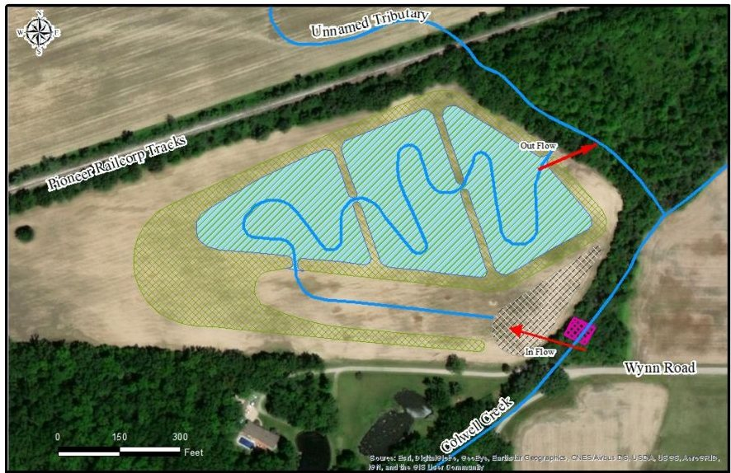

Project Goal (1/4 page)

The goal of this project is the development of a mechanistic nutrient and contaminant fate and transport tool for use in designing EWN projects that reduce the export of nutrients, contaminants, and suspended sediments to receiving waterbodies. The project will leverage ERDC's distributed watershed, sediment, nutrient, and contaminant modeling capabilities provided by the Gridded Surface Subsurface Hydrologic Analysis Program (GSSHA), the Nutrient Simulation Module (NSM), and the Contaminant Simulation Module (CSM), respectively. Nutrient and contaminant capabilities are currently being developed within GSSHA for overland, channel, and upper sub-surface regimes; however, no efforts are underway to incorporate sediment and water quality fate and transport within the deeper sub-surface components of GSSHA; the Vadose zone, groundwater and tile drain modules within GSSHA. This project will address this capability gap, creating a unique modeling tool and providing simulation capabilities that do not currently exist in any watershed modeling system.

## Statement of Need (1/4 page)

Extensive modifications of the landscape in the continental U.S. Great Plains and Midwest for agriculture has significantly changed the hydrologic, sediment transport, and water quality characteristics of watersheds and streams in the region. This has had profound effects on streams, rivers, lakes, and reservoirs in the region, with erosion/sedimentation and water quality concerns in most areas with extensive agricultural modifications to the landscape resulting in increased flooding, stream instability, and impaired use of water bodies for recreation, drinking water, and aquatic species. Half of U.S. streams and rivers contain excess nutrients, with only about a third assessed as healthy. While the problem is large, so is the potential for EWN-informed solutions. The agricultural setting presents an ideal arena for incorporation of EWN for watershed management and abatement of both emerging and long-standing water issues. However, placement of EWN in agricultural settings can be costly and ineffective if improperly placed or designed. This project will provide missing capabilities to do this properly. The project also supports ERDC Strategic Areas Comprehensive Integrated Hydro-Terrestrial Risk Management, Innovations in Sediment Management, and NextGen Water Resources Infrastructure.

## Problem or Opportunity (1/4 page)

Current watershed models either do not address the effects of standard agricultural features, such as tile drainage, or do so in very simplistic, empirical ways, (i.e., through modification of model parameters to “mimic” the effects of tile drains within the watershed). The proposed project develops a tool that that captures the input physical systems, such as drainage ditches and tile drain networks to the model computational domain and simulates the fate and transport of suspended sediments, nutrients, and contaminants across the watershed, through the Vadose zone, through the tile drain network, into ditched system and to downstream waterbodies or EWN infrastructure. These new modeling capabilities will produce more detailed and accurate EWN projects designs (e.g., Constructed Wetlands) that allow land managers to better target and mitigate adverse effects of farming operations on ecosystem services and aquatic health metrics of downstream waterbodies.

## Project Value Statement (1/4 page)

Roughly 50 percent of the continental U.S. is devoted to agriculture. Runoff from agriculture contributes millions of tons of nutrients – along with pesticides, bacteria, and sediments to water bodies – including those managed by the USACE. This project will greatly enhance the ability of the USACE to evaluate the potential application of EWN features in tile-drained agricultural settings and improve understanding of how natural infrastructure (NI) can be leveraged to improve the use of nature-based features (NBS) in agricultural environments. In addition to assessment, the tool will be useful for engineering design and implementation of EWN features in watersheds containing USACE managed water bodies, as well as along, and potentially within, these waterbodies, helping to meet required load reduction objectives for water bodies affected by agricultural runoff. While various EWN features are used in agricultural settings, the placement and design are ad-hoc, may not provide the desired result, waste precious resources, and negatively impact future efforts to properly implement EWN in the same areas. The project also supports ERDC Strategic Areas Comprehensive Integrated Hydro-Terrestrial Risk Management, Innovations in Sediment Management, and NextGen Water Resources Infrastructure.

## How Does the Project Align with the EWN Program (1/4 page)

Engineering With Nature is the intentional alignment of natural and engineering processes to efficiently and sustainably deliver economic, environmental, and social benefits through collaboration. In the agricultural environment, natural and engineered management features such as wetlands, vegetation strips, detention basins, and infiltration basins, are harnessed to reduce flooding, manage sediments, and improve water quality. Our proposed work will develop state-of-the-art assessment and engineering design tools, a specific Wave II EWN strategic goal, to assess/demonstrate how natural processes in agricultural regions can be leveraged to broaden benefits within the watershed. While application of the developed tool will be relevant to other geographical areas, this project will focus on the Midwest and Great Plains. Collaboration with USACE district offices and state management agencies will be facilitated by this work; further collaboration, down to the individual farmer scale, will be facilitated through state and local agencies in the tool demonstration phase, as outlined in goals listed under Waves 1 and 3.

## How Does the Project Satisfy EWN Elements

The project satisfies the four EWN elements, as described below:

|  |  |
| --- | --- |
|  | Leverage Natural Processes (1/4 page) |
| Flooding, erosion, and associated water quality problems arise when peak flows exceed the natural system’s capacity. In the agricultural landscape, flooding, erosion, and water quality impairment are caused by the modification of the natural processes and can be counteracted by reducing runoff and slowing the water down to allow the processes of sediment and contaminant settling, filtering, decay and transformation to proceed by using designed EWN features such as wetlands, detention basins, vegetative filtration strips, etc. This project fulfills these needs by providing process-based analysis of the current system as well as allow the siting and design of EWN features that best meet project goals. | | |
|  | Produce Efficiencies (1/4 page) |
| Current watershed models do not allow the explicit simulation of sediment and constituents in a heavily modified agricultural landscape. Manmade features, of relatively fine scale, ditches and tile drain networks completely modify and dominate system response. These effects and the counteracting effects of EWN cannot be adequately analyzed with simple empirical approaches to simulating these features. In this project, we propose to greatly increase the efficiency of analyzing the current system, siting and designing EWN features, and determining the best configuration to meet project goals providing a process-based approach capable of explicitly simulating the fine-scale agricultural features that control the fate and transport of water, sediment, and contaminants in the agricultural setting. This will be accomplished by extending the existing suspended sediment and nutrient and contaminant fate and transport processes into the Vadose zone, groundwater and tile drain models of the GSSHA model, resulting in a complete EWN design tool. | | |
|  | Broaden Benefits (1/4 page) |
| The products generated by this project will allow optimization of EWN design features that minimize water quality impacts due to farming operations. By more accurately simulating flow, sediment, nutrient, and contaminant runoff through modified landscape, decision makers will be better equipped to quantify potential environmental impacts as well as design and implement EWN infrastructure that function as intended and remain sustainable over a wide range of storm events. EWN features in an agricultural setting, can be expensive to implement and operate. The risk of getting it wrong is large because project sponsors and those responsible for implementing EWN features, which may be individual farmers, may not be unwilling to participate in future efforts if the implemented features do not produce desired results. This emphasizes the need for proper analysis in the beginning so that maximum benefit is derived by sponsors and stakeholders. | | |
|  | Collaboration (1/4 page) |
| The project team builds on a history of successful work with USACE district partners, such as the St. Paul and Buffalo Districts, to model watersheds in agricultural setting with tile drain and ditch networks, as well as other agricultural features and help develop mitigation strategies (e.g., constructed wetlands) to reduce the impacts of farming operations on downstream waterbodies (e.g., Minnesota River and Lake Erie). The team already closely works with the Minnesota Department of Environmental Protection (DEP), the University of Minnesota, and MVP on these issues. This tool may be applied to other constructed wetlands projects associated with tile-drained agricultural lands, e.g., Lemke et al. (2022). The team will continue collaborate with current partners and develop new relationships with other partners to ensure that the resulting tool meets the current needs of districts, state and local agencies, non-profits, and individual commercial concerns to develop “real world” demonstration studies to illustrate the application and benefits of these vital new modeling capabilities. | | |

# Project Objectives and Outcomes

## Objectives (1/4 page)

The broad objective of this project is to facilitate the use and design of sustainable EWN projects in intensively hydrologically altered agricultural areas in the Great Plains and Midwest regions. We intend to advance the use of EWN in these areas by developing and demonstrating an analysis tool to identify the potential for EWN to provide benefits for water bodies in the regions.

1. Develop an advanced modeling tool, the EWN Engineering Design Tool, will allow farmers to:
   1. Optimize operations (e.g., tillage practices)
   2. Application of fertilizers
   3. Design tile drains to more efficiently remove water from fields
   4. Mitigate excess suspended sediments, nutrients, and chemicals to downstream waterbodies through the use of EWN features such as constructed wetlands, bio-swales, etc.
2. Develop a demonstration study to verify that the model is performing satisfactorily and will meet the needs of agricultural land managers.

## Technical Approach (2 pages, including figures)

The Gridded Surface Subsurface Hydrologic Analysis (GSSHA) is the USACE’s fully distributed, physics-based watershed analysis model. GSSHA is applicable to a wide range of engineering and environmental applications, such as flood analysis, flood control, erosion and erosion control, and computing total maximum daily loadings and pollution abatement (Downer et al., 2014). GSSHA simulates overland, stream, and transport. GSSHA includes features specifically related to the simulation of these processes in the agricultural setting, including simulation of tile drain systems. A subsurface storm drain model, called SUPERLINK, has been incorporated into GSSHA to allow the model to explicitly include the effects of subsurface drainage networks. Representing subsurface drainage networks as channel flow, overland flow, or within the groundwater parameters can lead to significant errors when simulating watersheds with subsurface drainage features. In SUPERLINK, as implemented in GSSHA, flow to the subsurface system can originate from surface openings or subsurface tile drains. In agricultural settings, tile drains are used to lower the local water table below the crop root depth and exert a dominant influence on hydrology. Water, sediments and associated agricultural contaminants can enter into the system at surface inlets. Because the tile drains are porous, water and contaminants can enter into the tile drains when the saturated groundwater level is higher than the tile drain elevation. Tile drains are typically placed parallel within agricultural fields at some specified spacing, *L* (m), as shown in Figure 1. The tile drains result in a drawdown of the local water table around the tile drainpipes, Figure 1. The drainage to tile from groundwater under this common condition can be calculated with one of two optional methods, the U.S. Department of Agriculture (USDA) DRAINMOD method or Cooke method. Both methods are considered accurate; user preference would therefore dictate the selection of methods.

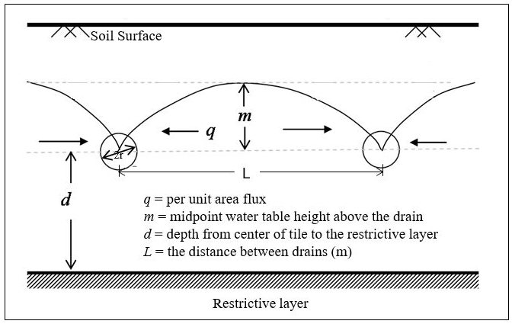

Figure 1. GSSHA Tile Drain Schematic

A library of nutrient simulation processes has been developed by ERDC (Zhang et al, 2016a): **NSM-I** simulates algal biomass, simple nitrogen and phosphorus cycles, organic carbon, carbonaceous biological oxygen demand, dissolved oxygen and pathogen. Two options exist for each state variable: simulated and bypassed. Any combination of water quality constituents can be included or excluded from the simulation. **NSM-II** simulates multiple algal biomass, complete nitrogen, phosphorus, carbon and silica cycles, dissolved oxygen, carbonaceous biological oxygen demand (CBOD), pathogens, alkalinity, and pH. In addition, NSM-II couples the water column simulation with a benthic sediment diagenesis module. Sediment-water fluxes of dissolved oxygen and nutrients are simulated internally rather than being prescribed. Any number of generic constituents, suspended solids groups, and CBOD groups can be simulated with NSM-I and NSM-II, as shown in Figure 2.

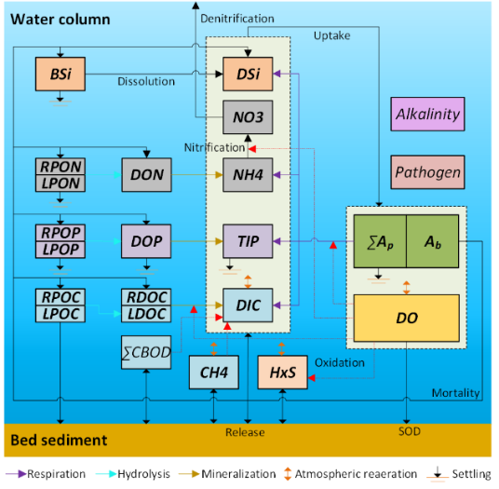

Figure 2. NSM II Schematic

A Contaminant Simulation Model (CSM) has been developed (Zhang et al, 2016b) to simulate the fate and transport of chemicals and metals within the environment, Figure 3. CSM allows for a solid constituent as well as constituents that are dissolved, sorbed to sediments, and sorbed to particulate organic matter (POM). Various decay processes are simulated depending on the specific chemical or metal.

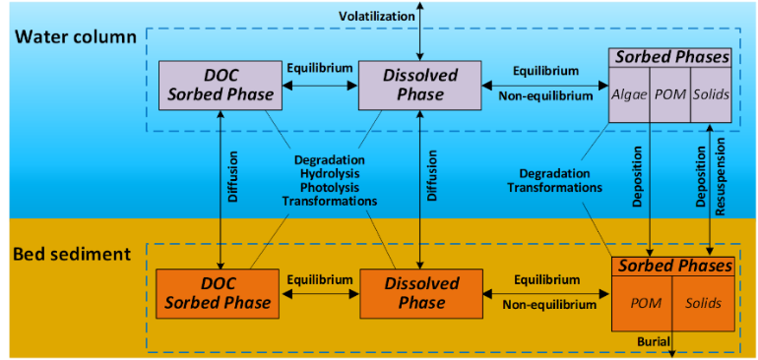

Figure 3. CSM Schematic

Current development projects are implementing nutrient and contaminant processes for overland, channel, and upper soil layer/channel bed layer regimes. This project will leverage those efforts to implement the required water quality processes into the Super Link module, Vadose zone module, and Groundwater module within GSSHA and to ensure output is sufficient to be used as input for the development of EWN infrastructure modules (e.g., Constructed Wetlands, Bio-swales, Vegetated filter strips, etc.).

## Collaboration (1 page)

We will conduct a demonstration of tool capabilities in a watershed with active USACE, state, and local interest in watershed management, such as the Minnesota River, Seven Mile Creek sub-watershed (Downer et al, 2020) in St. Paul District, currently the focus of a Silver Jackets study. Demonstrations provide an opportunity to collaborate with USACE districts, state and local governments, and landowners regarding selection of a demonstration site, arranging of monitoring (if needed), and determining goals and scenarios to be simulated. Additional ongoing collaboration with Minnesota state agencies and University of Minnesota will be maximized in both tool development and application. The Seven Mile Creek Watershed lies in the Middle Minnesota River Basin in Nicollet County in Minnesota (Figure 4 and Figure 5). The Seven Mile Creek drainage area comprises 91 km2. This predominately agricultural watershed is characterized by uplands and ravines at the interface with the River Warren Escarpment in the downstream portion. Soils are primarily clay loam categorized as Des Moines Lobe Till. The Middle Minnesota River contributes approximately 9 percent of total suspended solids (TSS), 10 percent of detected nitrogen (N), and 5 percent of the phosphorous (P) loads to the Minnesota River (Minnesota State University Mankato 2003). The watershed has undergone substantial hydrological modifications, including extensive networks of subsurface drains. The GSSHA model was used previously within the watershed to simulate flow, sediment, and nutrient transport, understand the controlling processes, and analyze potential mitigation strategies. The MN DEP continues to develop and use GSSHA models for other watersheds in the basin for similar problems so the opportunities for technology transfer are high.

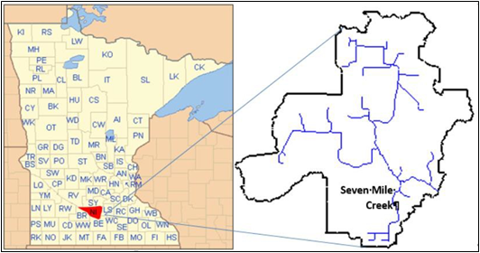

Figure 4. Seven Mile Creek Watershed located in Nicollet County, Minnesota.

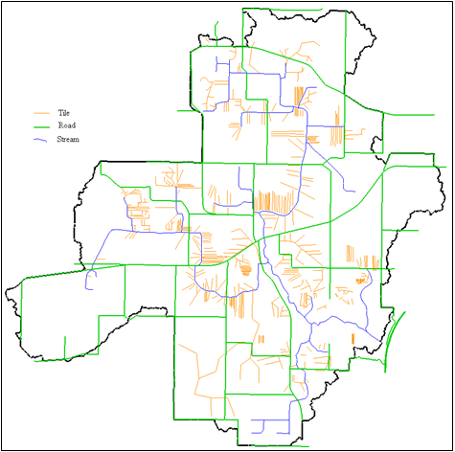

Figure 5. Drainage network of streams, ditches, and subsurface drain tiles

throughout Seven Mile Creek.

## Activities, Deliverables, POCs, and Schedule (1/2 - 1 page)

Task 1 - Develop Design Plan for Integrating nutrient and contaminant processes with Super Link and Vadose zone within GSSHA – In order to efficiently integrate nutrient and contaminant fate and transport processes into GSSHA, a design plan documenting relevant process descriptions and team member responsibilities will be developed and published as an ERDC Technical Note.

Task 2 – Develop transport capabilities in the Vadose zone and tile drain networks for suspended sediments, nutrients, and contaminants – Currently flow is routed through the Vadose zone and the tile drain networks however transport capabilities are needed to simulate the movement of suspended sediments, nutrients, and contaminants through these regimes.

Task 3 - Integration of NSM with Vadose zone module – Relevant NSM processes will be integrated into the Vadose zone module. This will be necessary in order to provide boundary conditions for the Super Link module from pore water concentrations.

Task 4 - Integration of CSM with Vadose zone module - Relevant CSM processes will be integrated into the Vadose zone module. This will be necessary in order to provide boundary conditions for the Super Link module from pore water concentrations.

Task 5 - Integration of NSM with Super Link – Nutrient fate and transport processes will be integrated with the Super Link module. Output will be sufficient to provide nutrient information for the simulation of EWN infrastructure models/modules.

Task 6 - Integration of CSM with Super Link - Contaminant fate and transport processes will be integrated with the Super Link module. Output will be sufficient to provide contaminant information for the simulation of EWN infrastructure models/modules.

Task 7 – Development of time varying Ground Concentrations – Currently GSSHA assumes that the Groundwater nutrient and contaminant concentrations are static and change very slowly, if at all, over time. We will investigate if this is a valid assumption for agricultural landscapes and if need be develop capabilities within GSSHA to account for monthly or seasonal changes in Groundwater concentrations.

Task 8 - Testing and Debugging of NSM integration with GSSHA – Testing and debugging of nutrient routines will be performed to ensure model is producing reasonable results.

Task 9 - Testing and Debugging of CSM integration with GSSHA - Testing and debugging of contaminant routines will be performed to ensure model is producing reasonable results.

Task 10 - Development and Execution of Seven Mile Creek Demonstration Study – In coordination with our collaboration partners, the PDT will leverage the previous study model and data in order to test and validate the new GSSHA tile drain capabilities.

Task 11 - Conferences/Journals – At least one conference presentation and one journal article publication will be completed in conjunction with this project.

Task 12 - Workshop with USACE District Personnel – In coordination with district personnel, a workshop will be developed to train interested personnel on the new model capabilities. It is anticipated that most personnel interested in attending this workshop will have some experience with GSSHA.

## Communication and Technology Transfer Plan (1/2 – 1 page)

**ERDC Publications** – Technical Notes and Technical Reports will document designs, technical formulations, testing and debugging, and validation of the new GSSHA tile drain capabilities.

**ERDC GitHub** – The ERDC GitHub site will be used to manage and coordinate all software development activities. This will ensure that the PDT is able to efficiently work on various aspects of the code and seamlessly merge their efforts.

**ERDC Laboratory Web Sites** – When new software capabilities are ready for dissemination, laboratory web sites will be used to notify potential users and provide access to release versions of GSSHA.

**Conference** – At least one conference will be selected for presenting the new GSSHA tile drain capabilities to the larger modeling community. It is anticipated that the selected conference will maintain an emphasis on EWN topics.

**Journal Article** – An appropriate journal will be selected, and a joint PDT journal article will be developed, submitted, and published.

**Workshop** – A workshop will be conducted for interested personnel. It is anticipated that participants will have previous experience with GSSHA, facilitating a focus on the new tile drain capabilities. In the workshop, we will discuss new process descriptions while also providing hands-on training using the Seven Mile Creek watershed datasets. Discussions of how to take output from the model will be conducted to demonstrate how EWN infrastructure can be used to reduce impacts from agricultural activities on downstream waterbodies.

## Expected Benefits and Impact (1/4 to 1/2 page)

Currently no watershed model allows explicit modeling of sediments and contaminants in tile drain networks in agricultural watersheds. This project will provide more accurate water quality information to downstream EWN infrastructure or waterbodies, which will in turn allow for better, and more sustainable, EWN infrastructure designs and enable better estimation of impacts from agricultural practices on affected waterbodies. Existing tile drain networks can be assessed and optimized to perform as intended; new tile drain networks can also be designed to improve flow, sediment, and water quality functionality within the affected watershed. Better realization of project goals enhances acceptance of implementing EWN features in the agricultural setting, which may be costly and initially not accepted by farmers or other local interest. Being able to visually see the projected results in a realistic looking setting can help ease resistance, as can successfully implementing EWN projects.

## Cited References (1/2 page)

Downer, Charles W., Nawa Raj Pradhan, and Aaron R. Byrd, 2014. “Modeling Subsurface Storm and Tile Drain Systems in GSSHA with SUPERLINK,” ERDC/CHL TR-14-11.

Downer, Charles W., Mark Wahl, Nawa Raj Pradhan, Brian Skahill, Stephen Turnbull, and Ryan Pickett, 2020. “Nested Physics-Based Watershed Modeling at Seven Mile Creek

Minnesota River Integrated Watershed Study,” ERDC/CHL TR-20-3.

Lemke, A. Maria, Krista G. Kirkham, Adrienne L. Marino, Michael P. Wallace, David A. Kovacic, Kent L. Bohnhoff, Jacqueline R. Kraft, Mike Linsenbigler, and Terry S. Noto, 2022. Accelerating Implementation of Constructed Wetlands on Tile-Drained Agricultural Lands in Illinois, United States. *Soil and Water Conservation: A Celebration of 75 Years*.

Winnick, M. J., 2021. Stream transport and substrate controls on nitrous oxide yields from hyporheic zone denitrification. *AGU Advances*, 2, e2021AV000517. https://doi. org/10.1029/2021AV000517

Zhang, Zhonglong and Billy E. Johnson, 2016a. “Aquatic Contaminant and Mercury Simulation Modules Developed for Hydrologic and Hydraulic Models,” ERDC/EL TR-16-8.

Zhang, Zhonglong and Billy E. Johnson, 2016b. “Testing and Validation Studies of the NSMII - Benthic Sediment Diagenesis Module,” ERDC/EL TR-16-11.

# Schedule and Funding

## Overall Requested Funding

|  |  |  |  |  |  |
| --- | --- | --- | --- | --- | --- |
| Fiscal Year | Q1 ($K) | Q2 ($K) | Q3 ($K) | Q4 ($K) | TOTAL ($K) |
| FY23 | 0 | 0 | 125 | 55 | 180 |
| FY24 | 50 | 175 | 50 | 45 | 320 |
| FY25 | 25 | 175 | 25 | 25 | 250 |
| FY26 | 25 | 125 | 25 | 25 | 200 |
| Total Budget: | **100** | **475** | **225** | **150** | **950** |

## Requested Funding by Cost Type

*Indicate the funding requested for labor, subcontractors, travel, equipment, and any other costs.*

|  |  |  |  |  |  |
| --- | --- | --- | --- | --- | --- |
| Cost Type | FY23 ($K) | FY24 ($K) | FY25 ($K) | FY26 ($K) | Total ($K) |
| LABOR COSTS |  |  |  |  |  |
| EL | 16 | 30 | 60 | 43 | 148 |
| CHL | 0 | 86 | 56 | 43 | 185 |
|  |  |  |  |  |  |
| OTHER COSTS |  |  |  |  |  |
| LimnoTech Inc. | 150 | 120 | 120 | 100 | 490 |
| Purchases | 0 | 0 | 0 | 0 | 71 |
| Travel | 10 | 10 | 10 | 10 | 40 |
| Publication | 4 | 4 | 4 | 4 | 16 |
|  |  |  |  |  |  |
| TOTAL | **180** | **250** | **250** | **200** | **950** |

## Requested Funding for Project Activities

*See Appendix A table.*

## Cost-Sharing or In-Kind Contributions (1/2 page)

It is anticipated that the St. Paul District, Minnesota state and local governments, individual landowners, and the University of Minnesota will contribute in-kind services such as previous model studies, observed data collection, and access to demonstration field sites. Final in-kind funding amounts will be determined upon acceptance of this full proposal.

## Risk Management (1/2 page)

There are no dependencies involved with the model development, testing, and debugging. The development of the features will be carefully managed by EL and CHL to ensure that the work is proceeding as planned. Risk will be managed by defining intermediate products and check points in the SOW. Validation of the new model capabilities using the Seven Mile Creek Watershed will depend upon the participation of the collaborative partners mentioned previously. The past work relationship with the partners and the previous model study conducted by CHL minimize any risks associated with the demonstration study.

# Project Delivery Team Members

## Principle Investigator Point of Contact

Name: Todd E. Steissberg, PhD, PE

Title: Research Environmental Engineer

Email: todd.e.steissberg@usace.army.mil

Phone: 530-574-5572

Org. Code: U433D90

## Project Delivery Team

*Describe the project delivery team and their roles using the table below, including the financial point of contact if the project is funded. Provide a ½ page biography for each PDT member in Appendix B that includes a description of education, relevant experience and products, prior achievements/successes.*

|  |  |  |
| --- | --- | --- |
| PDT Member | Organization (e.g. Lab, Division, Branch) and Organization Code | Project Role |
| Todd Steissberg, Todd.E.Steissberg@usace.army.mil, 530-574-5572 | ERDC-EL-EPW, U433D90 | PI, water quality design, report preparation |
| Chuck Downer, Charles.H.Downer@usace.army.mil, 305-458-8443 | ERDC-CHL, U430510 | Co-PI, hydrology design, report preparation |
| Nawa Pradhan, Nawa.Pradhan@usace.army.mil, 601-634-3837 | ERDC-CHL, U430510 | Hydrology and water quality design, analysis and testing |
| Billy Johnson, Billy.E.Johnson@erdc.dren.mil, 601-415-6299 | LimnoTech, Inc. | Water quality capability development, case study |
| Aaron Byrd, Aaron.R.Byrd@erdc.dren.mil, 601-634-2666 | ERDC-CHL, U430510 | GSSHA development, code improvements, code management |
| Rose Shillito,  [Rose.M.Shillito@erdc.dren.mil](mailto:Rose.M.Shillito@erdc.dren.mil)  Phone: 601-634-7628 (office), 301-325-9810 (mobile) | ERDC-CHL, ORG: U430550 | Subsurface water quality research for model algorithm development and model validation |
| Ann Banitt, Ann.M.Banitt@usace.army.mil, 651-290-5541 | USACE-MVP | Coordination with staff from District and state/local agencies to provide field data and information on project needs |
| John Hargrave, John.G.Hargrave@usace.army.mil, 402-995-2347 | USACE-NWO | Coordination with staff from District and state/local agencies to provide field data and information on project needs |
| Salam Murtada, Salam.Murtada@state.mn.us, 651-259-5151 | Minnesota Department of Natural Resources | Advice, assistance, and review of the EWN modeling tool; field data |
| Steve Kloiber, Steve.Kloiber@state.mn.us, 651-259-5155 | Minnesota Department of Natural Resources | Advice, assistance, and review of the EWN modeling tool; field data |
| Kayla Rushing, [kayla.k.rushing@usace.army.mil](mailto:kayla.k.rushing@usace.army.mil),  601-634-3241 | ERDC-EL-EZM | Financial POC |

## EWN Proposal Submission

Please submit proposals to [EWN-USACE@usace.army.mil](mailto:EWN-USACE@usace.army.mil) with the subject “**FY22 EWN Proposal Submission**.” Please also rename the completed long proposal document as follows: ***LastName*_*TitleAbbreviation*_EWN-FY22-Full-Proposal_*YYYYMMDD*.doc.**

# Appendix A: Summary Table of Activities, Deliverables, Communication Plan, and Budget

|  |  |  |  |  |  |  |
| --- | --- | --- | --- | --- | --- | --- |
| Activity | Deliverable | Communication/Technical Transfer Plan | Lead POC | Anticipated Start Date (quarter and year) | Anticipated End Date (quarter and year) | Estimated Budget for Completion |
| Task 1. Develop Design Plan for Integrating nutrient and contaminant processes with Super Link, Vadose zone, and Groundwater within GSSHA | Design document for use in directing integration activities. | Published ERDC Technical Report | Todd Steissberg | 3rd/FY23 | 4th/FY23 | $75k – FY23 |
| Task 2. Develop transport capabilities in the Vadose zone and tile drain networks for suspended sediments, nutrients, and contaminants | Updated GSSHA Model | ERDC GitHub Site, Coastal and Hydraulics Laboratory Web Site | Chuck Downer | 3rd/FY23 | 2nd/FY24 | $65k – FY23  $10k – FY24 |
| Task 3. Integration of NSM with Vadose zone module | Updated GSSHA model | ERDC GitHub Site, Coastal and Hydraulics Laboratory Web Site | Chuck Downer | 3rd/FY23 | 2nd/FY24 | $110k – FY23  $40k – FY24 |
| Task 4. Integration of CSM with Vadose zone module | Updated GSSHA model | ERDC GitHub Site, Coastal and Hydraulics Laboratory Web Site | Chuck Downer | 2nd/FY24 | 1st/FY25 | $150k – FY24  $50k – FY25 |
| Task 5. Integration of NSM with Super Link | Updated GSSHA model | ERDC GitHub Site, Coastal and Hydraulics Laboratory Web Site | Chuck Downer | 3rd/FY24 | 2nd/FY25 | $50k- FY24  $25k – FY25 |
| Task 6. Integration of CSM with Super Link | Updated GSSHA model | ERDC GitHub Site, Coastal and Hydraulics Laboratory Web Site | Chuck Downer | 1st/FY25 | 4th/FY25 | $75k – FY25 |
| Task 7. Development of time varying Ground Concentrations | Updated GSSHA model | ERDC GitHub Site, Coastal and Hydraulics Laboratory Web Site | Chuck Downer | 1st/FY25 | 4th/FY25 | $50k – FY25 |
| Task 8. Testing and Debugging of NSM integration with GSSHA | Updated GSSHA model, Technical Note | Published ERDC Technical Note | Todd Steissberg | 3rd/FY25 | 2nd/FY26 | $25k – FY25  $25k – FY26 |
| Task 9. Testing and Debugging of CSM integration with GSSHA | Updated GSSHA model, Technical Note | Published ERDC Technical Note | Todd Steissberg | 3rd/FY25 | 2nd/FY26 | $25k – FY25  $25k – FY26 |
| Task 10. Development and Execution of Seven Mile Creek Demonstration Study | Seven Mile Creek GSSHA model, Technical Report | Published ERDC Technical Report | Nawa Pradhan | 1st/FY26 | 4th/FY26 | $75k – FY26 |
| Task 11. Conferences/Journals | Conference Papers, Journal Articles | Conference Publications and Presentations, Published Journal Articles | Todd Steissberg | 1st/FY26 | 4th/FY26 | $25k – FY26 |
| Task 12. Workshop with USACE District Personnel | Workshop | Workshop | Chuck Downer | 1st/FY26 | 4th/FY26 | $50k – FY26 |
| TOTAL BUDGET: | | | | | | $950k |

# Appendix B: PDT Biographies

Provide a ½ page biography for each PDT member that describes their education, relevant experience and products, and prior achievements/successes related to the EWN Program or EWN elements. Please include a headshot photo for each member.

**Dr. Todd Steissberg** is a Research Environmental Engineer at the U.S. Army Engineer Research and Development Center’ Environmental Laboratory (ERDC-EL). He is currently leading a team that is developing water quality and vegetation simulation and analysis capabilities for hydraulic and hydrologic modeling programs. These are being used to solve complex water quality and ecosystem restoration problems in river systems, including the Missouri River Basin, the Columbia River Basin, and the Minnesota River Watershed. Dr. Steissberg is also collaborating to develop satellite-based tools for geospatial ecosystem assessment. A major goal of his research and development activities is to provide interdisciplinary teams with the tools needed to perform integrated watershed-scale water quality assessments, which serve a critical role in real-time water management, planning studies, environmental impacts analysis, and ecosystem restoration. Dr. Steissberg received his BS in Civil Engineering from Washington State University, where he performed air pollution research and aquatic ecosystem restoration design. He received his MS and PhD in Civil and Environmental Engineering from the University of California, Davis, as a NASA Earth System Science fellow at NASA/JPL on research in satellite remote sensing, physical limnology, and water quality. He also served as a hydraulic engineering intern at the U.S. Army Corps of Engineers (USACE) Sacramento District, designing aquatic ecosystem restoration and fish passage projects. Dr. Steissberg performed postdoctoral research at the UC Davis John Muir Institute of the Environment, Tahoe Environmental Research Center, before joining the staff of the USACE Hydrologic Engineering Center (HEC). At HEC, Dr. Steissberg was a senior research hydraulic engineer, the lead of water quality modeling, and a team lead/member on multiple hydrology, hydraulics, and geospatial projects.

Dr. Charles W. Downer is a leading researcher in water resources for the US Army Engineer Research and Development Center (ERDC). At this position Dr. Downer leads scientific teams in the development and application of numerical models to solve complex water resources problems including flood control, water supply, sediment and contaminant control, and ecosystem restoration. His developments and studies have been published in more than 100 reports, conference proceedings and refereed journal articles. He is also an author of multiple chapters in books on hydrology and is an author on the 2013 National Climate Assessment. Dr. Downer holds a B.S. from La. Tech University with a major in Civil Engineering and minors in Mathematics and Economics, a M.S from University of Texas at Austin with a major in Environmental and Water Resource Engineering and a minor in Mathematics, and a PhD from the University of Connecticut in May 2002 with a major in Environmental Engineering and a minor in Mathematics. Dr. Downer is registered as a Professional Engineer (PE) in the state of Mississippi and holds an internationally recognized credential as a Project Management Professional (PMP). Dr. Downer has demonstrated his leadership skills in a variety of roles. At ERDC he leads multiple research teams and is the lead for civil works hydrology at ERDC and has received multiple awards for project success and technical transfer. Dr. Downer has also been the senior hydrologist for Everglades National Park where he led scientific teams studying and advocating for Everglades restoration, and has worked for the engineering consulting firm, Espey, Huston, & Associates, where he also developed and applied hydrologic, hydraulic, and water quality models. Dr. Downer completed the CES Advanced Leadership Development course in 2019 and intends to continue his leadership development through the use of the Senior Executive Talent Management (SETM) program.

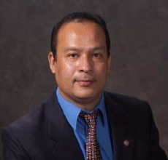Dr. Nawa Pradhan is a Research Hydraulic Engineer for US Army Engineer Research and Development Center (ERDC). In his academic career, he served as adjunct professor and post-doctoral researcher before joining ERDC in Feb 2011. Theories and models developed by him includes SERVES Model (Soil moisture Estimation of Root zone through Vegetation index-based Evapotranspiration fraction and Soil properties), OPM Model (One Parameter hydrological Model), STATS Model (Scaling of Topographic Area and Topographic Slope). He has also included several hydrological processes (including hydro-thermodynamics, evapotranspiration, sediment transport capacity formulations etc.) in the US Army Corps of Engineers GSSHA (Gridded Surface and Sub-surface Hydrological Analysis) hydrological model. He did his PhD in Civil Engineering from Kyoto University, through Monbukagakusho Scholarship. During his academic and professional career, he is awarded with several national and international awards that includes ERDC- Research and Development Achievement award, AWRA Boggess award, Japan Society of Civil Engineers’ Young Scientist award, Nepal Bidhya Bhusan. He is a topic editor for journals Water and Remote Sensing.

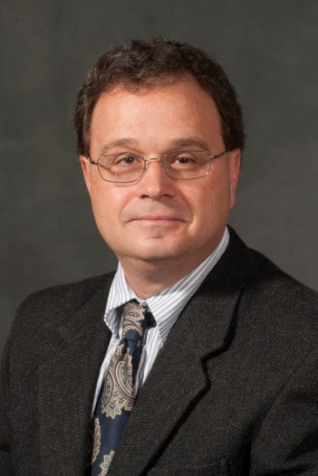Dr. Billy Johnson is a Senior Scientist at LimnoTech with broad expertise in Water Resources, including successful leadership of projects involving the development and application of sediment, nutrient, contaminant, and riparian vegetation simulation modules for civil works and military projects. These modules have been integrated with a variety of U.S. Army Corps of Engineers (USACE) hydraulic and hydrologic modeling systems. He has over 35 years’ experience as a research civil engineer, educator, and consultant for projects across the U.S. In addition, he has been involved in developing U.S. Army Installation Energy and Water Plans (IEWP), Flood Mapping and Mitigation Plans for Overseas DoD Installations in data poor regions, and Low Impact Development (LID)/Nature Based Features projects for DoD installations. Billy previously served as a senior researcher at the U.S. Army Engineer Research and Development Center (ERDC), Environmental Laboratory (EL). In addition to working for EL, he also worked for the ERDC Coastal and Hydraulics Laboratory (CHL), and the Memphis District USACE. He was an adjunct faculty member at Mississippi State University and served as an Associated Editor of the Journal for the American Water Resources Association (JAWRA). Dr. Johnson currently resides and works in Vicksburg, MS.

Dr. Aaron Byrd is a Subject Matter Expert (SME) for hydrologic modeling and data analysis. He works for the Hydrologic Systems Branch within the US Army Corps of Engineers-Engineering Research and Development Center in Vicksburg MS. Dr. Byrd has worked over the past decade and a half on creating and improving watershed modeling tools for the US Army Corps of Engineers. Dr. Byrd’s areas of expertise lie in hydrologic modeling, numerical simulations, programming, and software usability. Dr. Byrd has been the co-developer of the Gridded Surface Subsurface Hydrologic Analysis (GSSHA) model. Key areas of model advancement he has worked on include boundary conditions, constituent transport, inset modeling capabilities, and parallelization of the code. Over the years Dr. Byrd has created hydrologic models for many parts of the world. He has done work in Texas, New Mexico, Utah, California, Mississippi, Louisiana, Wisconsin, Minnesota, Illinois, Georgia, as well as several OCONUS area such as Great Britain, Europe, and Asia. Dr. Byrd’s current work has two tracks. The first is the development of extreme hydrologic analysis techniques and tools. The second is to create new web-centric resources for developing and deploying models, visualization environments, and access to supercomputing capabilities. Dr. Byrd recently returned from a civilian deployment to Afghanistan where he was a senior advisor to the Ministry of Interior Facilities Director and technical manager for $120M of police facilities construction. Dr. Byrd has many publications as author or co-author. One recent noteworthy example is that he was the lead author for a chapter in the new Handbook of Applied Hydrology. Dr. Byrd has received many awards, including two ERDC R&D awards, the ERDC Technology Transfer award, and the ERDC Teamwork award. Dr. Byrd received an Achievement Medal for Civilian Service for his work on Hurricane Katrina flooding New Orleans. He also received the Commander’s Award for Civilian Service for his work on modeling forecasted flooding from Superstorm Sandy.